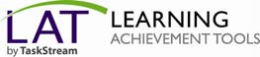

Self-Enrolling into Programs

Copyright © 2002-2010. TaskStream All Rights Reserved - 1 -

Self-Enrolling into Programs

Welcome!
You have been selected to participate in a TaskStream program. The program code that has been issued to you is intended for your use only. To enroll yourself into a TaskStream program, follow the directions below.

Log In
Go to www.taskstream.com and log into your TaskStream account.

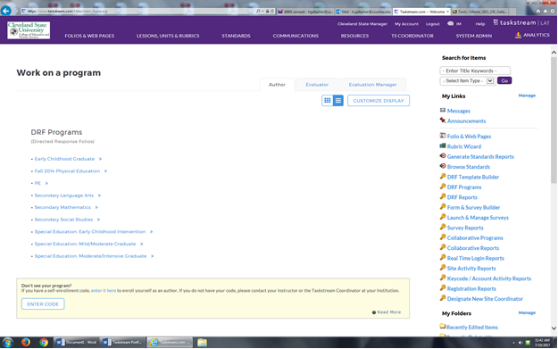

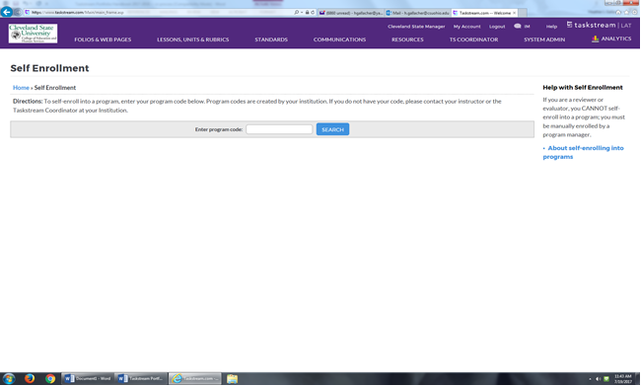

Enter Your Code

1. To be enrolled in the program, click Enroll. If you do not want to be enrolled in the program at this time, click Cancel - Do Not Enroll.

If you have any additional questions or comments, please do not hesitate to contact Mentoring Services at help@taskstream.com or at 800-311-5656, or for help at CSU, contact Heather Gallacher at 216 687 3743 or email at h.gallacher@csuohio.edu

Program | Self-enrollment Code
Chinese | CSUCHIFA2012
Early Childhood Grad | CSUECGFA2012
ECIS Grad | CSUECISFA2012
Mild/Moderate Grad | CSUMMGFA2012
Moderate/Intensive Grad | CSUMIGFA2012
Music | CSUMUSFA2012

